The story of SMOLENKA

We have established our family company on 21. 12. 2012, although the story of the ointment made from the spruce resin had started much more early, probably at the end of the 19th century. It was in times when it was common to seek help from all diseases and ailments in nature, instead of pharmacies. Our story begins with our great-grandfather Alois Vošta, who was born in 1900 in a small cottage in Balková Lhota, a small village in the South Bohemia.

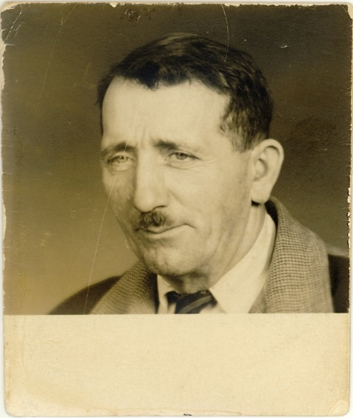
Alois Vošta
There he lived with his family and he learned from his mother Kateřina Voštová how to cook ointment made from spruce resin. This ointment became very popular in the surroundings because it had great proven healing effects.

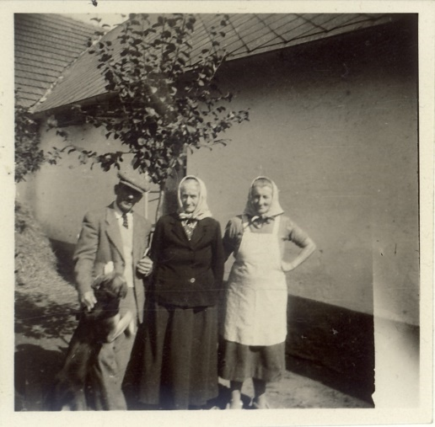
Alois Vošta with his mother Kateřina ( in the middle)

Alois Vošta passed the recipe and the whole production process to his granddaughter Květuše Klacendová born Voštová, who tells us stories about memories of her grandfather. ““I still have in live memory when I, as a small child, watched my grandfather Alois while cooking the ointment. I remember the mysterious atmosphere and smell. People from the village went to Grandpa Lojza for ointment considered as a rarity. At that time, it helped them with almost everything they had on their body. From broken knees, inflamed nails, sore teeth, cracked heels, cracked hands, backs, frostbite, cuts and other wounds of all kinds, acne to leg ulcers and foot mold. Successfully they used ointment for animals as well. It perfectly cleaned and healed everything. ”

The beneficial effects of our ointment are verified by several generations of local people from nearby and distant surroundings. Much time has elapsed since the time of the great-grandfather Alois, but we still use the same raw materials and techniques for the production of spruce resin ointment. We are very glad that today we can offer our customers a natural ointment that can help as much as they have helped before. We try to prove that the power of nature is often larger and more gentle than chemical preparations from the pharmacy.

Our miracle Spruce resin ointment, which we offer to our customers today, we called „Smolná mast“ and besides it we also started to produce „Smolný krém“ (cream), a product also made of spruce resin. We produce the ointment and cream by hand and use only natural ingredients. What is the difference between our products?
The active substance of spruce resin, contained in both products, is a natural substance with a strong antibacterial and antifungal effect.

In the ointment, the resin is more potent and very suitable to calm red skin with a tendency to inflammation and skin problems. Also suitable for problematic skin with tendents to acne. It very effectively takes on unpleasant problems caused by ingroting nails. It is very effective in combating fungal problems eg. Nails and feet. Furthermore, the ointment helps on poorly healing wounds, nail perforations, abrasion and other inflammatory problems.

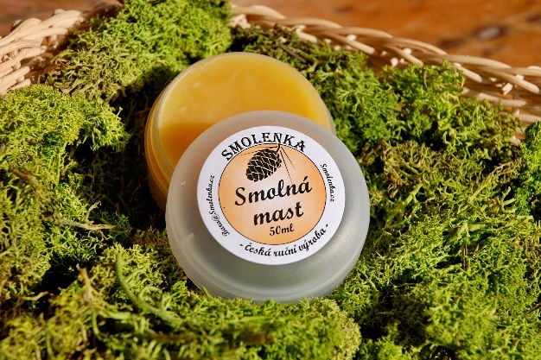
The ointment
The cream, with a smaller content of spruce resin, is suitable for regenerating the skin and providing it with perfect care. Very suitable for skin care when the appearance of eczema and psoriasis. The presence of shea butter ensures hydration and moisturising of the skin, and together with almond oil, the cream is a great helper for very dry and cracked skin. A regular wrap of the feet from the resin cream can prevent strong horn, cracked heel and preventively the protection of the nails and soles.

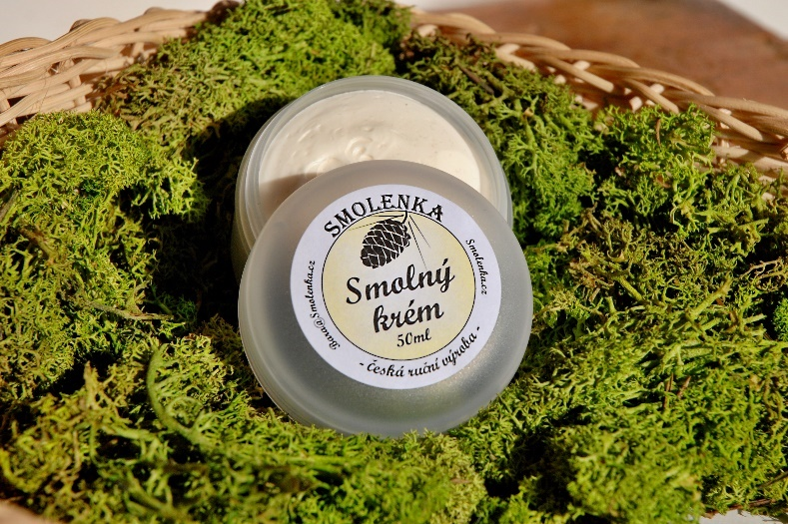
The cream
The resin of coniferous trees, was from the ancient times sought-after raw material with versatile utilization, including in medicine. Over time, however, the subconscious of people slowly, but surely began to fade away, and today, only a few are remembered for her "miraceous" healing effects. The company is therefore extensively directed to use standardized chemical drugs. However, there are a few producers around the world who are often in the process of producing healing ointments from the content of resin, following their family tradition. This is also our case, we follow the traditional family recipe and we are very proud of the great-grandfather's legacy.

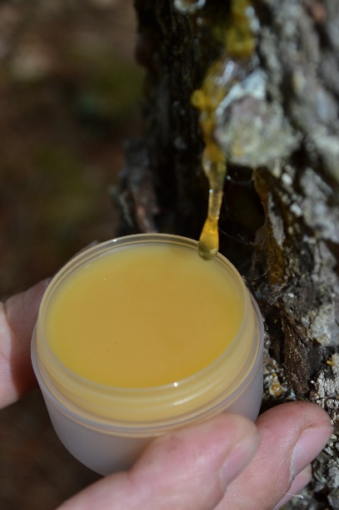
The resin from the spruce
The fact that the spruce resin has therapeutic effects proves also the research of Finnish physicians and scientists led by Dr. Arno Sipponen. They mainly dealt with the effect of natural treatment traditionally prepared by ointments of spruce resin to treat open and poorly healing wounds and ulcers. Compared to the classical chemical treatment of these problems, they concluded that treatment with spruce resin is more effective. Further research also confirms that spruce resin prevents mold growth and is very effective at treating mycosis (such as nails).
Our ointment and cream meet the safety requirements specified in regulation (EC) No 1223/2009 of the European Parliament and of the Council on cosmetic products. They have been treated with expert opinions on the health of cosmetic products for which the National Institute of Health has carried out the necessary laboratory tests.
In 2015 we also became part of the Association of Regional brands and our products are marked with the regional brand "TOULAVA regional Product"
We are very pleased with the news of our customers who write to us that our products have helped and we are often very pleasantly surprised to help with the problem we have not yet experienced.
Because we believe in our products, we enchanted the power of pure nature, support us with positive feedback and we want to move on, we decided to expand the range of products from spruce resin. We are currently finishing work for the approval of new statements by the State Health Institute. Customers can enjoy again only the natural composition of new statements of spruce resin soap, massage oil, relaxing sparkling baths, disinfectant sprays or bark for nail treatment. Other products are in our imagination for now, but we certainly want to expand the products with spruce resin. I hope that the spruce resin will regain its place in the subconscious of the company and that we will increasingly return to nature. We believe that today will help as in the past.

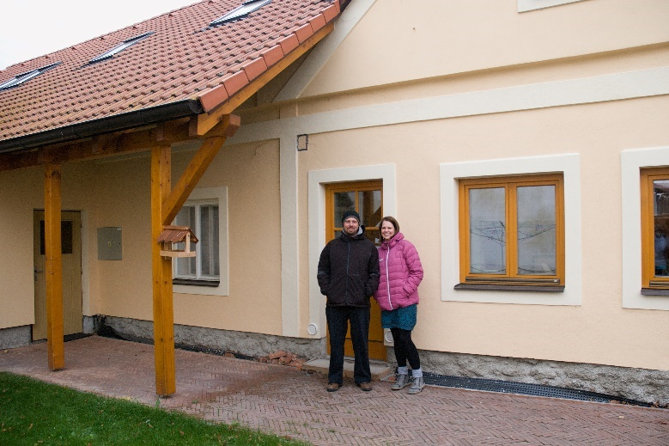
Smolenka
Barbora Klecandová
Mob: +420 775 301 910
email:bara@smolenka.cz
www.smolenka.cz

